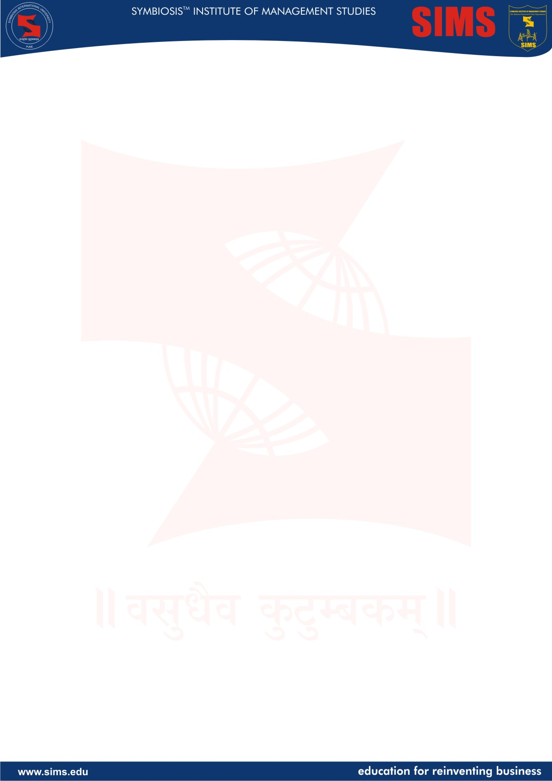

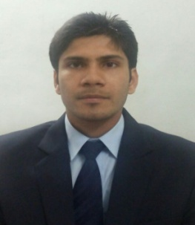
Ankit Kumar Jha
Marketting
27th June 1990/Male/Hindi, English

Education
Qualification | Institute | Board/University | Year of passing | CGPA/ Percentage
Graduation  (B Tech -CS) | Advanced Institute of Tech & Mgt , Faridabad | MDU | 2011 | 79.6
HSC | Central Academy , Kota | CBSE | 2007 | 78.00
SSC | Saint Thomas School | ICSE | 2005 | 84.00
Objective: Succeed in a challenging environment of growth and excellence and to utilize my skills and abilities in the domain to attain personal success and organizational development.

Key Projects

- Worked on NIIT Website during summer internship on Java [2009]
- B Tech final year assignment – Library management System ( Adv Java) [2010]
- Project based on Content Management system and SharePoint as major Project [2011]
- Created Website of the college and Barcode Managerial Event (UIdev and Java ) [2013]
Work Experience 24 Months

- Bata India beginner in marketing and sales – District Manager –Retail
- Have 24 months of experience in Cognizant Technology solutions as UI Developer. As part of assignments, have been involved in Web and Mobile Design Development & Testing in following Projects:
- Samba Arabic bank – UI and development , [2012]
- Birla Sun life mutual fund and life insurance UI dev and support,2012 [2012]
- Discover Mobile UI and Application – Android and IOS – Handset and Tablet [2013]
Achievements

- H1 Pat back and appreciation from client for performance in Discover Mobile Client
- Cleared Java Standard Edition 6 Programmer Certified Professional Exams
- Cleared Web Developers Certificate Cognizant
- Cleared W3schools Html and JQuery Certification with excellence certificates
- Amongst top performers of the college in engineering
Extra Curricular Activities

- IT cell coordinator at SIMS.
- Research Cell coordinator at SIMS
- Pranay(CSR) activities coordinator and team member at SIMS
- Active participation and achievements in various Sports and Athletics events
- Proactive participation in social services and voluntary blood donations
- Appreciations for anchoring and Event Organization and managements at college
- Active participation in social and cultural Events at college

